**AWS Lambda API Gateway:**

Step1: first I created one lambda function in aws lambda function.

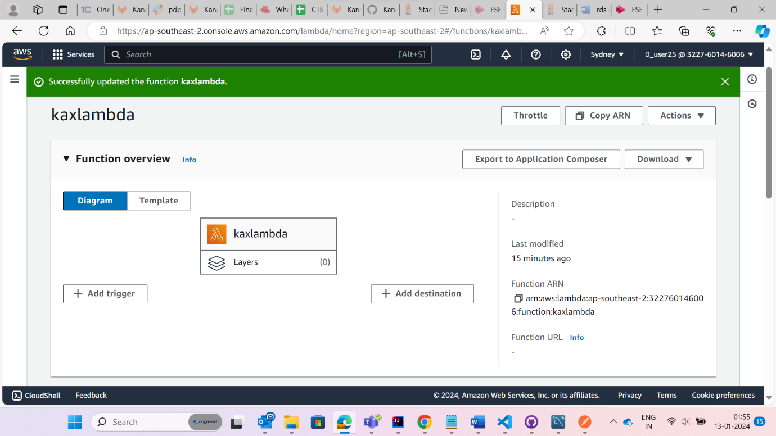

Step2: then I uploaded my jar file

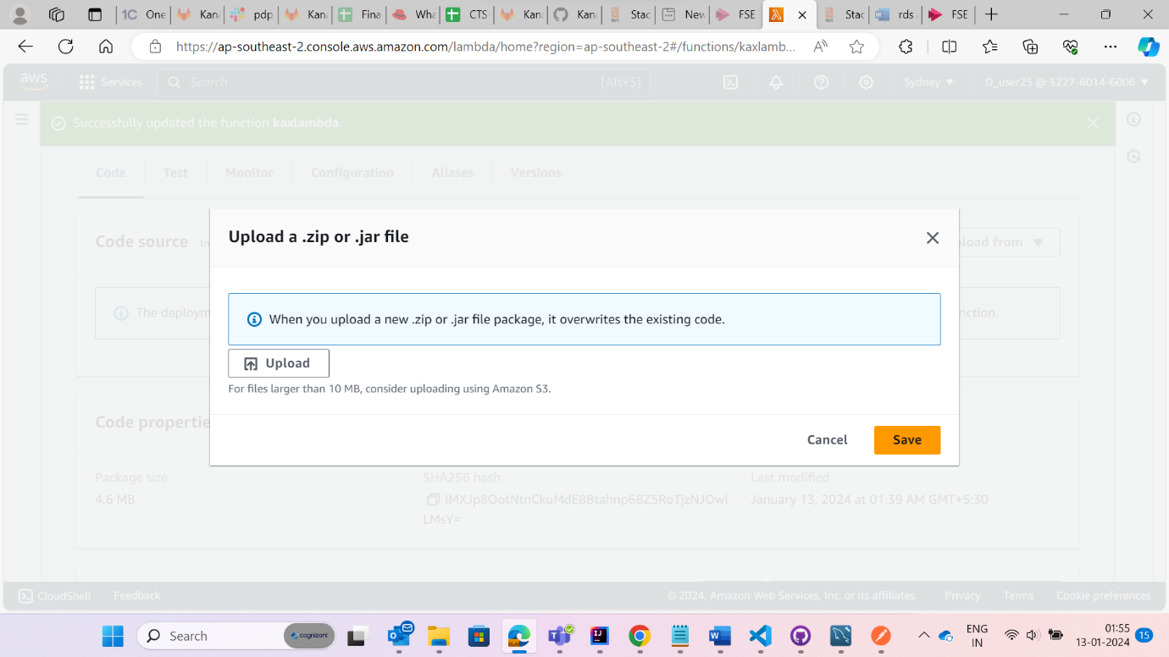

Step3: the click edit from Run time settings and give exact handler name and save it.

**Step4:**

Go to test and give test

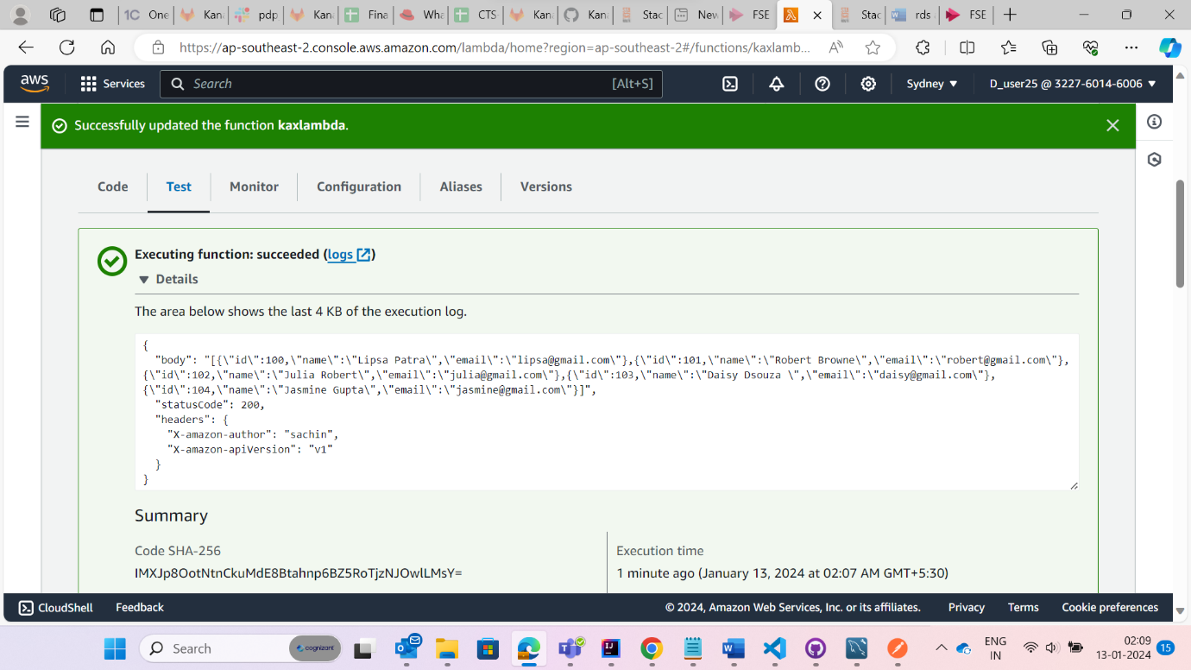

Step5:

Add triggers in that give api gateway and rest api open security and save it

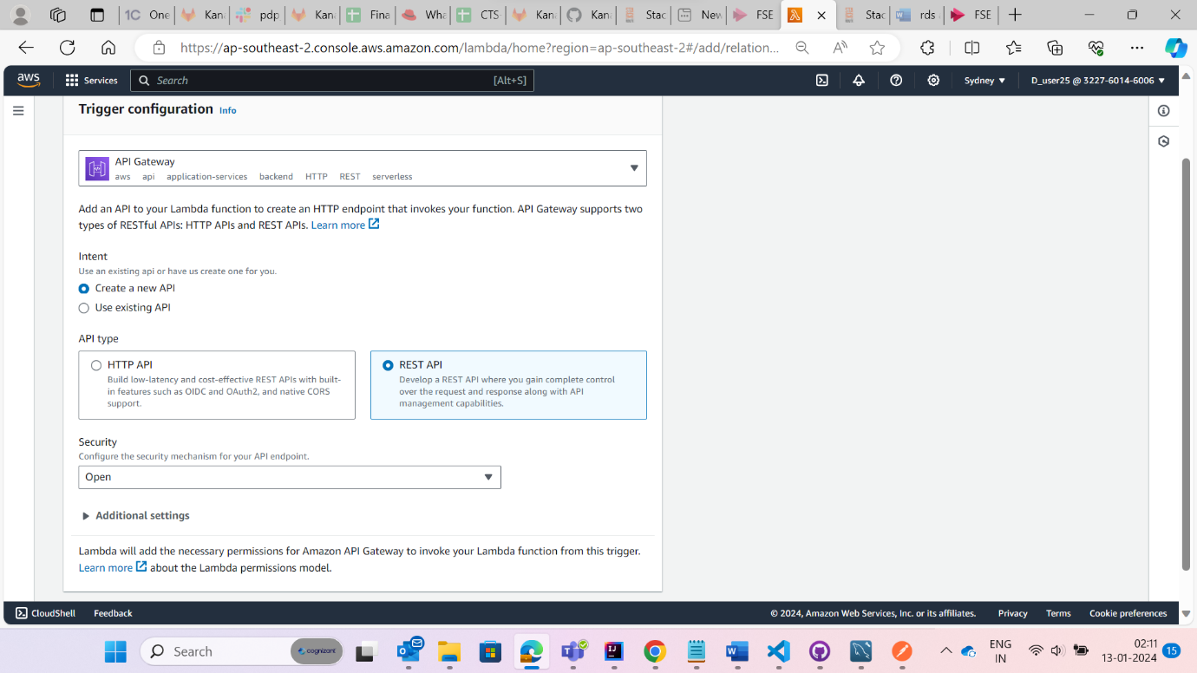

Step 6:

Here the api gateway



